**PhysX Pinball Game Documentation**

**Game design**

Overview: Pinball is a game that has been implemented both physically and electronically. The “Pinball Machine” comprises of a sloped cabinet and backboard, raised to roughly waist height by four legs. There are also many electronic renditions of the pinball game, where the machine is a 3D representation and is usually limited to just the cabinet and not the legs or backboard.

Scoring: The scoring in pinball games has varied greatly over the last 80 years due to the invention and application of new technology, changing how the score is displayed. A typical score per round has ranged from double digits all the way into the millions.

Main components:

* Pinball: The pinball is a simple spherical object, usually made out of metal due to its mass and low friction surface, allowing it to move around the play area quickly and rebound off surfaces easily.
* Plunger: The plunger is used to fire the pinball up a narrow shaft and into the play area. There are two main forms of the plunger; one being where the player pushes a button and the plunger shoots forwards, propelling the pinball up the shaft. With the other being where the player pulls the plunger backwards via a handle compressing the attached spring. When the player let’s go, the spring rapidly extends back to its rest position, pushing the plunger forward and propelling the pinball.
* Flippers: The flippers are usually the player’s only source of control when the game starts. They allow him/her to interact with the pinball by flipping it away from the drop zone and back into play. The flippers take the form of long thin wedges attached to a pivot point at the bottom of the play field, on either side of the drop zone. There is always a slight gap between the flippers which allows the pinball to fall through, if it is moving along the correct trajectory. The size of this gap is dependent on the manufacturer/designer and helps to set the difficulty of the game, i.e. the wider the gap, the harder the game.
* Obstacles and bounce pads: In the play area there are a number of obstacles that the pinball bounces off or reacts to in some way. These obstacles can take the form of anything from random shapes, to ramps and slides, to spinners or to rebounders that bounce the pinball rapidly away from them.

**Implementation**

**Scoring**

Once a round has begun, for every second that the pinball is in play 20 points will be added to the round’s score. Once the pinball is lost down the drop zone, the round will end and the points for that round will be deposited into the game’s total score. The player will have a total of 3 pinballs to earn as many points as possible, once the last pinball is lost, it is game over. To detect when a ball is lost down the drop zone, a custom trigger is placed in the area where the ball rolls back down to the plunger. When the ball passes through the trigger, the current round is ended, the round score is added to the total score and a life is removed. There is also a multiplier that can be used to greatly increase the number of points scored in the round. The round multiplier is increased by 0.5, every time the pinball hits any of the three red bonus pads and increases by 1.0 for every collectable that is picked up. The current round’s score and multiplier, along with remaining lives are displayed on the scene’s window. Doing this allows the player to see how well he/she is doing and helps improve engagement in the game.

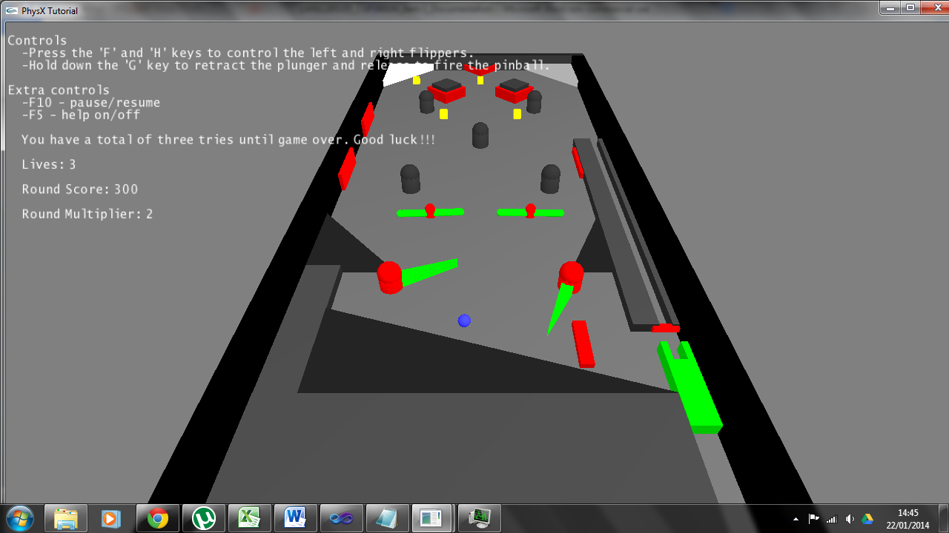

**Cabinet**

The cabinet forms the play area, along with housing for every object in the pinball game. It is created as a static object which means that it can’t be affected by either the forces in the game or by the player. This allows the game to be played without the cabinet falling apart. It is made out of a tall back panel, a shorter front panel and two side panels. The front and back panels use simple box geometry, but the side panels are sloped convex shapes and are created using an array of vertices. The base of the cabinet is sloped to allow the pinball to roll down towards the drop zone. As mentioned previously, most electronic pinball games don’t have legs or a backboard, so neither of these were added to the game, since they wouldn’t be in view of the player. There are 8 obstacles in the play area, 5 capsules and 3 boxes, all of which are static objects and part of the cabinet object forming a compound shape.

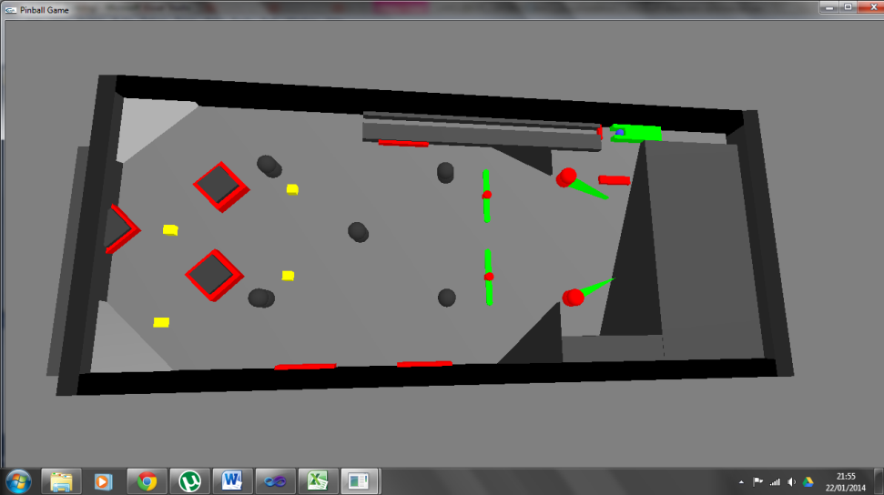 To prevent the pinball from getting hit out of play, an invisible lid is added to the scene, in the shape of a long box. It is a static object and rests right above the play platform, at a distance slightly more than the diameter of the pinball. This means that the pinball will appear to be pinned to the platform and won’t move away from it. Since the player will need to see through this lid so they can play, there is an additional check in the render code to check for the lid. When the render code reaches the lid object then it is skipped and not rendered creating an invisible object, allowing the lid to affect the objects in the scene whilst still allowing the player to play the game.

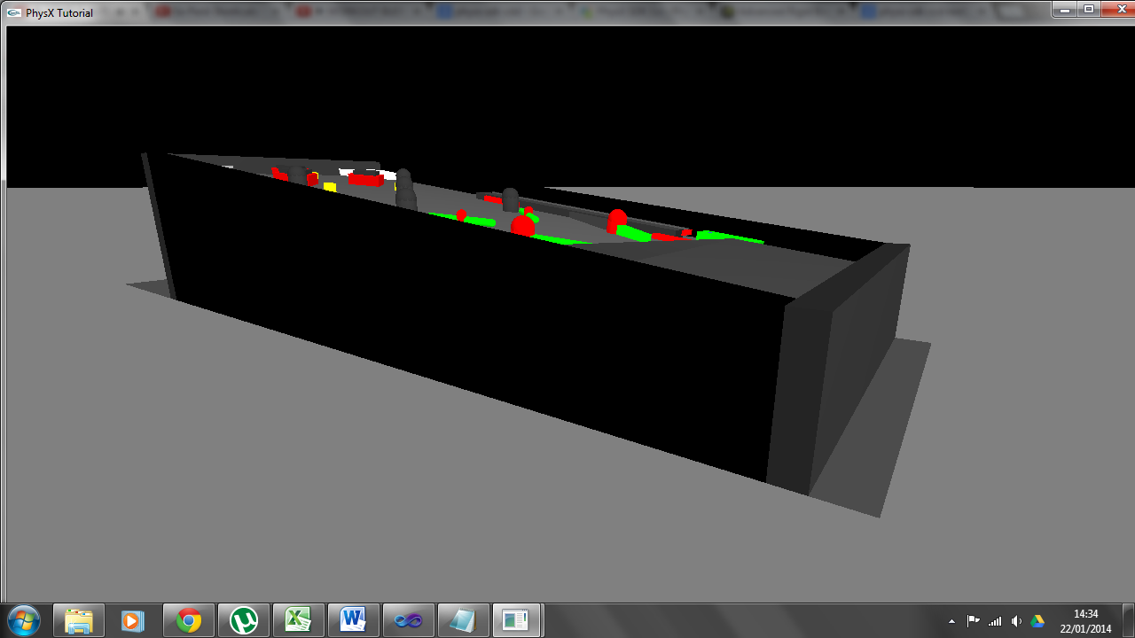

**Flippers**

The flippers are implemented using a convex mesh with predefined vertices, this creates a long thin wedge. This is attached to a rigid static capsule acting as the pivot point for the flipper. The objects are attached to each other using a spherical joint, which allows the wedge to rotate around the capsule pin in any direction and restricts any movement away from it. A spherical joint was used instead of a revolute joint to allow the flipper to freely rotate at the same diagonal angle as the sloped pinball base.

The player interacts with the flippers by pressing the ‘F’ and ‘H’ keys, with the F key controlling the left flipper and the H key controlling the right. Separating the controls in this manner, allows for a slightly more interactive experience since the player will need to decide which one he/she needs to activate. When either key is pressed, angular velocity is applied to quickly rotate the flippers forwards. If the pinball is within the radius of the flipper when this occurs, then it is flung away from the drop zone. A weaker force is constantly being applied to the flipper in the custom update function, in the reverse direction allowing it to return to its rest position once the corresponding key is released.

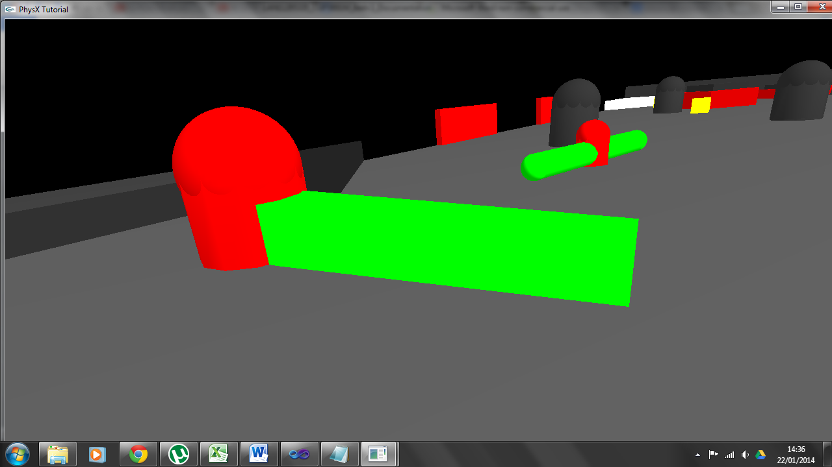

**Plunger**

The plunger comprises of a pole, two heads and an anchor point. The pole is created as a compound object and provides the mass to launch the pinball up the launch shaft and into play. The two heads located at the top of the pole are used to capture the pinball, keeping it in line with shaft, so it can be accurately launched. The anchor point is used to create a distance or spring joint between the anchor and the plunger. The anchor point is created as a kinematic object which means that it is unaffected by any forces present in the game. It is also set as a simulation object to allow the pinball to pass through it and not rebound off of it. The anchor is located at the top of the plunger shaft, with the plunger having a restitution position a small distance below.

To activate the plunger the player can hold down the ‘G’ key which applies a positive force along the z axis. This retracts the plunger to the bottom of the shaft building potential kinetic energy. Once the player releases the ‘G’ key, the plunger rapidly returns to its restitution position due to the forces created by the spring joint. Once the plunger reaches the top of the plunger shaft it gets blocked by the launch shaft and stops; the pinball then flies up it and enters the play area.

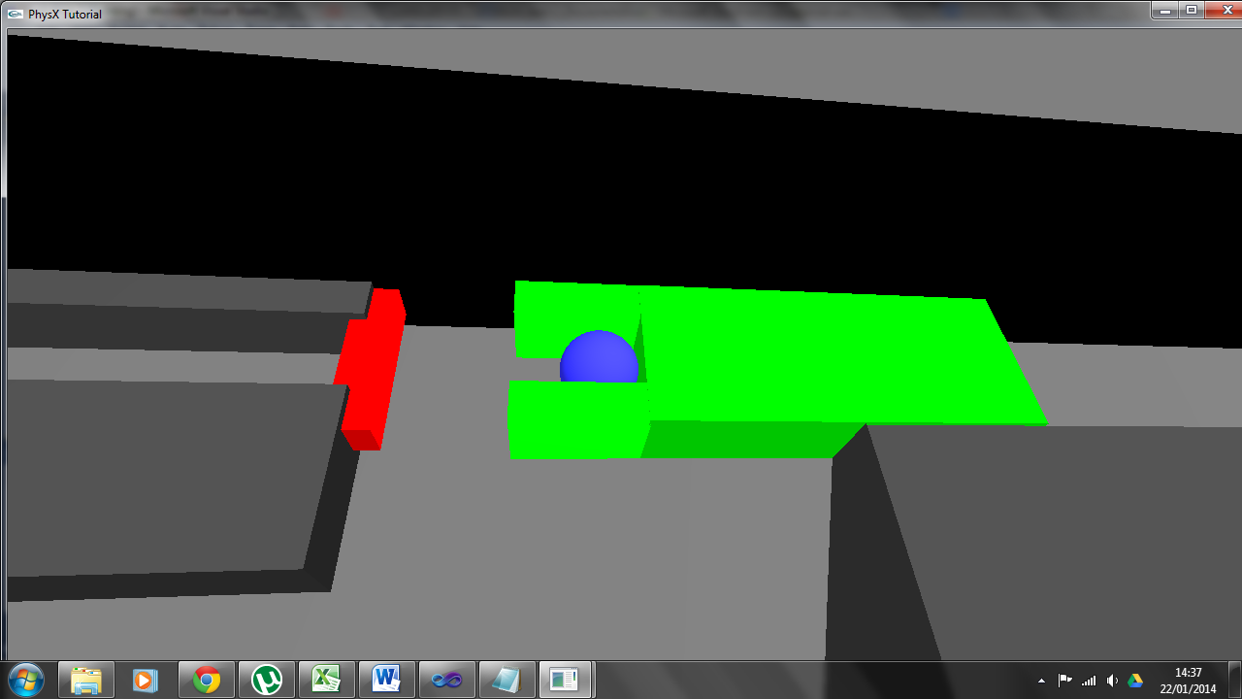

**Pinball**

The pinball is created using sphere geometry and since in most pinball games, it has very low friction, to allow it to rapidly move around the play area. The material used for the pinball in the simulation has very little static or dynamic friction. It also has a small amount of restitution added to it, making it more bouncy. These material properties allow the pinball to move in a similar manner to a real life pinball. To prevent the pinball from falling back down the plunger shaft, the area at the top of the shaft will apply a forward and sideways force to it if it enters the area.

**Bonus bounce pads**

There are three bonus bounce pads in the play area, two on the left wall and one on the right. When the pinball hits one of these pads, it is propelled either left or right (depending on which one it hits) and away from the pad. If the pinball hits one of these pads then a bonus of 0.5, is added to the current round’s multiplier, boosting the player’s score at the end of the round.

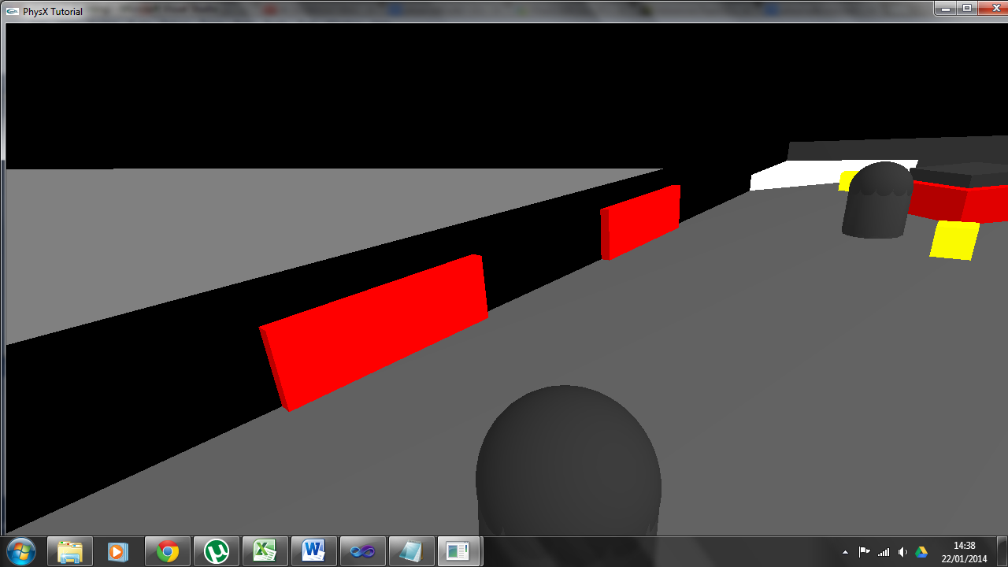

**Spinners**

There are two spinners positioned just above the flippers that rotate a thin capsule ‘arm’ around a capsule ‘pin’. The ‘pin’ capsule is made kinematic to allow the dynamic ‘arm’ to rotate around it, without either of them flying off. The left spinner rotates in an anti-clockwise direction, with the right spinner rotating in a clockwise direction. This means that the pinball will usually be hit up and away from the drop zone, increasing play time. The arm and the pin are attached to each other using spherical joints, again to allow for the same angle of movement as the flippers. To make the spinner arms rotate, torque (or rotational force) is added to them every ‘tick’ to maintain a steady and constant speed. If the pinball moves into either spinner’s radius, then it is hit and flung away from it.

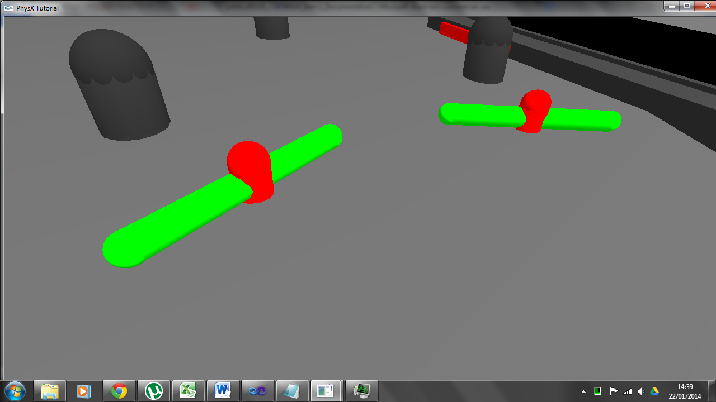

**Reload slide**

When the pinball is lost down the drop zone, it rolls down a convex slide made out of custom vertices. This allows the same pinball to be used throughout the game. Alternatively the pinball could be removed from play when it is lost and a new created, but since this isn’t the case with a real pinball machine, it seemed appropriate to just re-use the same ball.

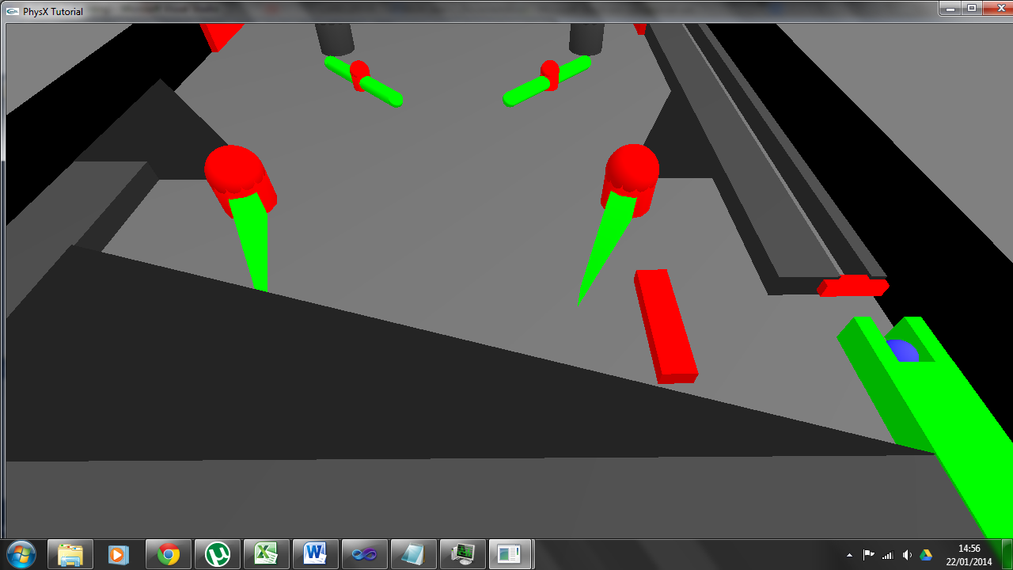

**Bumpers**

There are 3 cuboid bumpers located at the top of the play area; these push the pinball away if it touches them. To allow the pinball to rebound of the bumpers at a realistic angle, the current velocity of the pinball is calculated. This is accomplished by first finding the magnitude of the vector that the pinball is traveling along; then multiplying that number by the pinball’s current position. This velocity is then used to add a large force to the pinball along its current trajectory, propelling it into the bumper and allowing it to rapidly rebound at the correct angle.

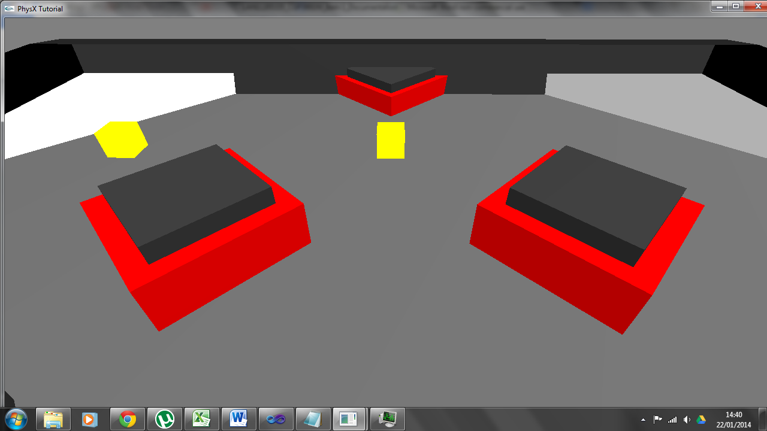

**Collectables**

To give the player something to aim for, a few collectables have been placed in the play area and take the form of yellow cubes. The cubes are made into to triggers that detect when the pinball passes through them; when this occurs, the collectable is removed and the score multiplier increase by 1.0, further increasing the player’s score.

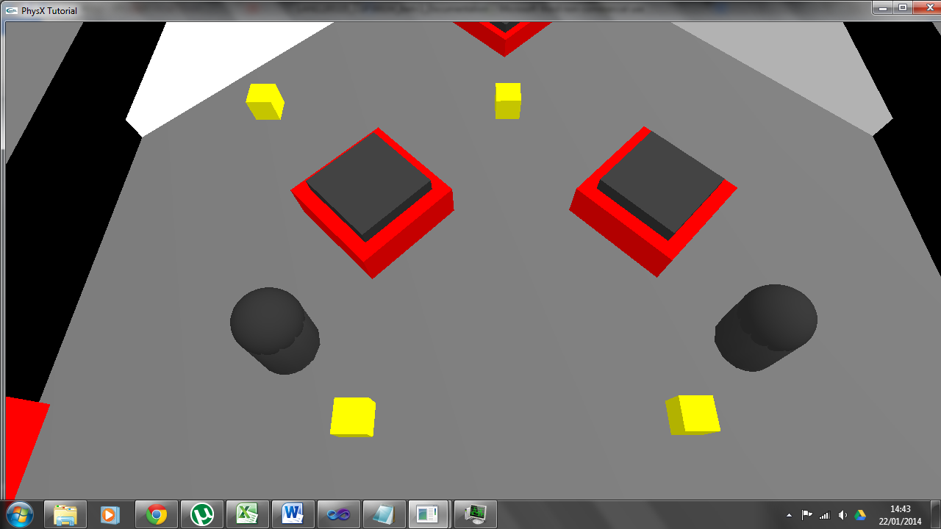

**Continuous collision detection**

Continuous collision detection or CCD is a solution to the problem where fast moving objects sometimes ‘clip’ through other objects and either get stuck inside or shoot out the other side. This issue is known as ‘tunnelling’ and can break the realism of a PhysX simulation. Once CCD is turn on, it can be activated for every moving object to prevent them from clipping through objects in the scene. For the pinball game CCD is activated for the pinball, plunger, flippers and spinners.

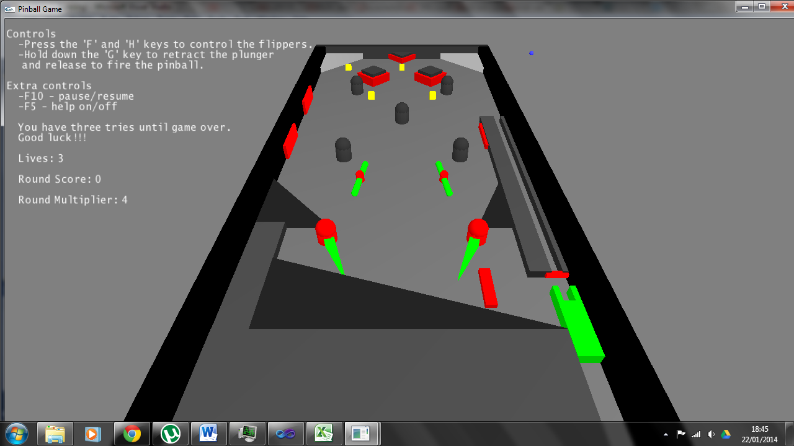

CCD turned off.

**Colour scheme**

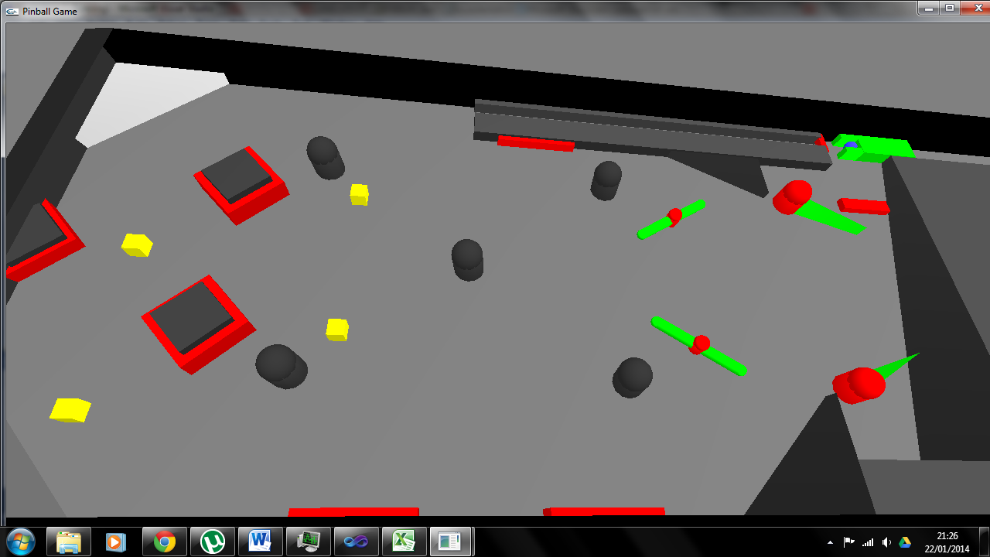The colour scheme of the simulation helps players to easily distinguish between different types of objects. The grey or black shapes are static objects and can’t be interacted with besides from the pinball bouncing off of them. The green objects are actively moving objects controlled by either the player or by the simulation. The red objects represent special functionality i.e. triggers and joints. The collectables are coloured yellow so they stand out from the other objects and because they can be seen as objects similar to gold coins or nuggets for example. The last object is the pinball, which is coloured blue, again different to the other objects so it stands out.

**Testing**

A total of 6 people were asked to play test the pinball game, where they each played one game that comprised of 3 lives. Once they lost their third ball then the game ended and their results are displayed on the scene’s window and the console window. A full breakdown of the results is displayed on the console window and is then copied onto a table, to clearly display their results. The variables listed below, are the metrics that were tracked:

Testing metrics:

* Total game score.
* Total game time.
* Score per ball (rounds: 1, 2 & 3).
* Time per ball (rounds: 1, 2 & 3).
* Time to score ratio.

|  |  |  |  |  |  |  |
| --- | --- | --- | --- | --- | --- | --- |
| Game 4 |  |  |  |  |  |  |
|  | Round | 1 | 2 | 3 |  |  |
|  | Base Score | 110 | 540 | 90 |  |  |
|  | Multiplier | 3.1 | 7.9 | 1.9 | Total Time | 01:31 |
|  | Total Score | 340 | 4266 | 171 | Total Score | 4777 |
|  | Time | 00:17 | 00:54 | 00:16 | Time/Score | 52.5 |

|  |  |  |  |  |  |  |
| --- | --- | --- | --- | --- | --- | --- |
| Game 8 |  |  |  |  |  |  |
|  | Round | 1 | 2 | 3 |  |  |
|  | Base Score | 1320 | 900 | 1480 |  |  |
|  | Multiplier | 5.5 | 4.5 | 7.5 | Total Time | 03:15 |
|  | Total Score | 7260 | 4050 | 11100 | Total Score | 22410 |
|  | Time | 01:10 | 00:50 | 01:15 |  | 115 |

|  |  |  |  |  |  |  |
| --- | --- | --- | --- | --- | --- | --- |
| Game 9 |  |  |  |  |  |  |
|  | Round | 1 | 2 | 3 |  |  |
|  | Base Score | 860 | 900 | 1960 |  |  |
|  | Multiplier | 3 | 4.5 | 10.5 | Total Time | 03:18 |
|  | Total Score | 2580 | 1020 | 20580 | Total Score | 24180 |
|  | Time | 01:02 | 00:26 | 01:40 | Time/Score | 122 |

|  |  |  |  |  |  |  |
| --- | --- | --- | --- | --- | --- | --- |
| Game 10 |  |  |  |  |  |  |
|  | Round | 1 | 2 | 3 |  |  |
|  | Base Score | 700 | 520 | 1160 |  |  |
|  | Multiplier | 5 | 2.5 | 5.5 | Total Time | 02:06 |
|  | Total Score | 3500 | 1300 | 6380 | Total Score | 11180 |
|  | Time | 00:39 | 00:27 | 01:00 | Time/Score | 88.7 |

|  |  |  |  |  |  |  |
| --- | --- | --- | --- | --- | --- | --- |
| Game 11 |  |  |  |  |  |  |
|  | Round | 1 | 2 | 3 |  |  |
|  | Base Score | 420 | 740 | 800 |  |  |
|  | Multiplier | 2.5 | 5 | 4.5 | Total Time | 01:54 |
|  | Total Score | 1050 | 3700 | 3600 | Total Score | 8350 |
|  | Time | 00:35 | 00:38 | 00:41 | Time/Score | 73.2 |

|  |  |  |  |  |  |  |
| --- | --- | --- | --- | --- | --- | --- |
| Game 12 |  |  |  |  |  |  |
|  | Round | 1 | 2 | 3 |  |  |
|  | Base Score | 620 | 1160 | 820 |  |  |
|  | Multiplier | 2.5 | 4 | 3 | Total Time | 02:25 |
|  | Total Score | 1550 | 4640 | 2460 | Total Score | 8650 |
|  | Time | 00:38 | 00:45 | 00:42 | Time/Score | 59.7 |

**Scoring**

Initially for every second that the pinball was in play, 10 points were added to the score and 0.1 was added to the score multiplier. To help determine whether the scoring should be left this way or whether the addition of 0.1 every second should be removed. Two test games were conducted, one for each scenario. The results are illustrated below:

Adding 0.1 every second.

|  |  |  |  |  |  |  |
| --- | --- | --- | --- | --- | --- | --- |
| Game 5 |  |  |  |  |  |  |
|  | Round | 1 | 2 | 3 |  |  |
|  | Base Score | 290 | 100 | 510 |  |  |
|  | Multiplier | 9.6 | 3.5 | 15.6 | Total Time | 01:38 |
|  | Total Score | 2496 | 350 | 7956 | Total Score | 10801 |
|  | Time | 00:37 | 00:10 | 00:51 | Time/Score | 110.2 |

Not adding 0.1 every second

|  |  |  |  |  |  |  |
| --- | --- | --- | --- | --- | --- | --- |
| Game 6 |  |  |  |  |  |  |
|  | Round | 1 | 2 | 3 |  |  |
|  | Base Score | 270 | 280 | 270 |  |  |
|  | Multiplier | 5 | 5 | 11.5 | Total Time | 01:23 |
|  | Total Score | 1350 | 1400 | 5855 | Total Score | 5855 |
|  | Time | 00:27 | 00:28 | 00:27 | Time/Score | 70.5 |

The results show that both games lasted similar lengths, but the score of ‘game 6’ was almost half that of ‘game 5’. It would be easier for the player to understand if only the score was increased for play duration, and the score multiplier was only affected when the pinball hit the bounce pads or picked up collectables. As mentioned in the scoring section in the game design section, pinball games usually have large scores, and scoring 10,000 points every minute would help the pacing of the game. Two achieve this, 0.1 will not be added to the score multiplier every second, and 20 points will be added to the score every second instead of just 10, to roughly give 10,000 score per minute. As seen in the results below:

|  |  |  |  |  |  |  |
| --- | --- | --- | --- | --- | --- | --- |
| Game 7 |  |  |  |  |  |  |
|  | Round | 1 | 2 | 3 |  |  |
|  | Base Score | 440 | 700 | 560 |  |  |
|  | Multiplier | 6 | 7.5 | 10 | Total Time | 01:35 |
|  | Total Score | 1980 | 5250 | 5600 | Total Score | 12830 |
|  | Time | 00:22 | 00:35 | 00:28 | Time/Score | 135 |

**User feedback**

**Comment:** “Pinball sometimes dropped down the hole next to the left flipper. Maybe put something there to stop it.”

**Solution:** An additional box was added to the scene to block this area and prevent the pinball from getting stuck there. It can still go behind the flipper, but the player can simply hold up the left flipper to allow the pinball to roll down the slide.

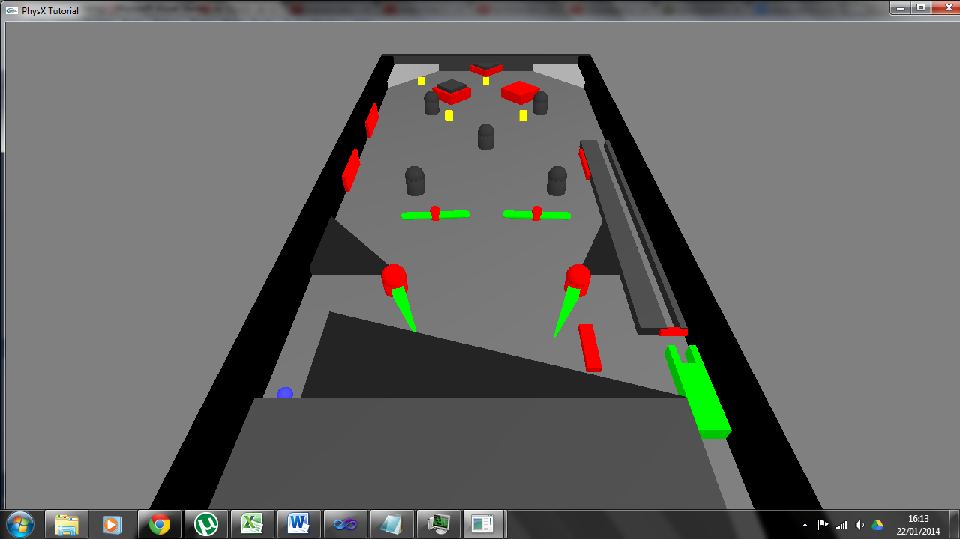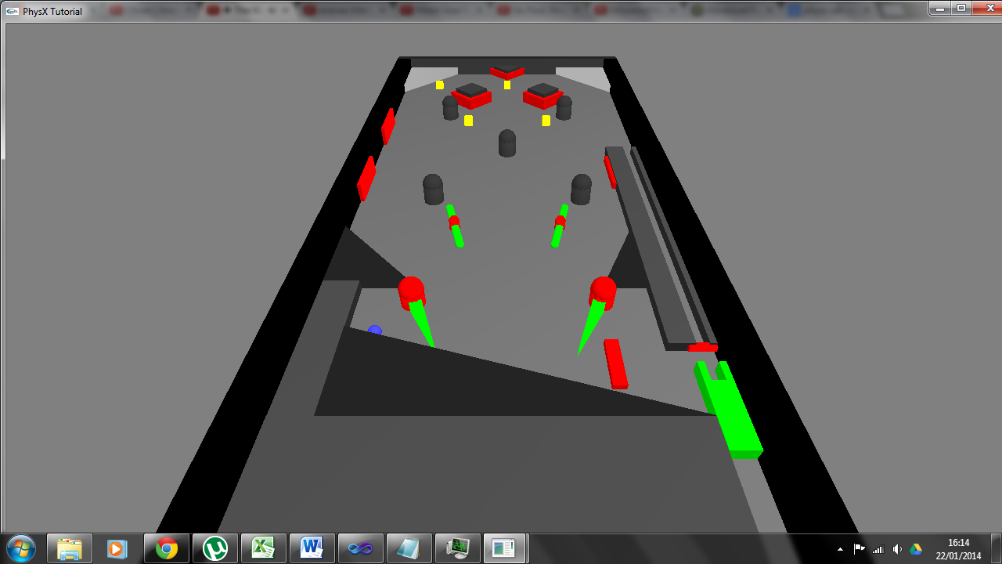

Original.

Fixed.

**Comment:** “The plunger is quite wobbly, try to make it steadier and not bounce around so much.”

**Solution:** The values corresponding to the joint’s stiffness and dampening, along with the force applied to retract the plunger, were modified to steady the plunger. It can only be steadied to a certain extent and remain powerful enough to launch the pinball; so a compromise between the two was made. The original figures were 80 for stiffness, 6 for dampening and 1000 for force, and the new values are 30 for stiffness, 3.5 for dampening and 600 for force. This makes it less powerful but steadier.

**Comment: “**When the ball has picked up a yellow cube remove it from the scene.”

**Solution:** When the pinball passes through a collectable, it is removed from the play area to prevent the same one being collected multiple times. This makes for more realistic collectables and allows the player to easily see if the pinball successfully hit one.

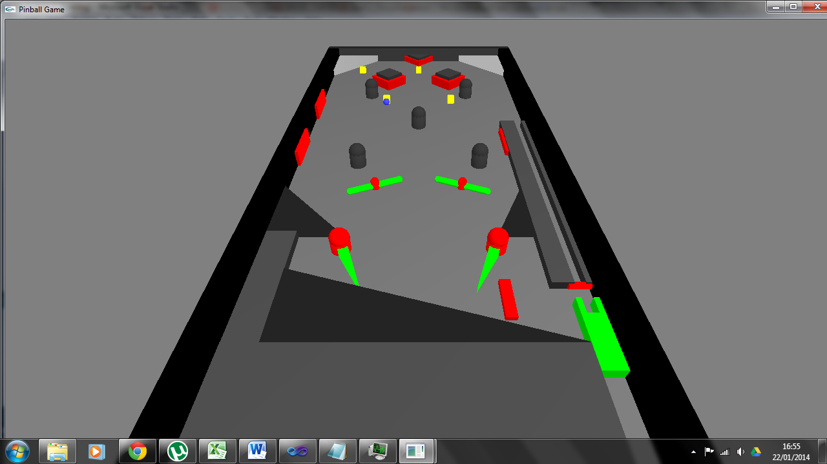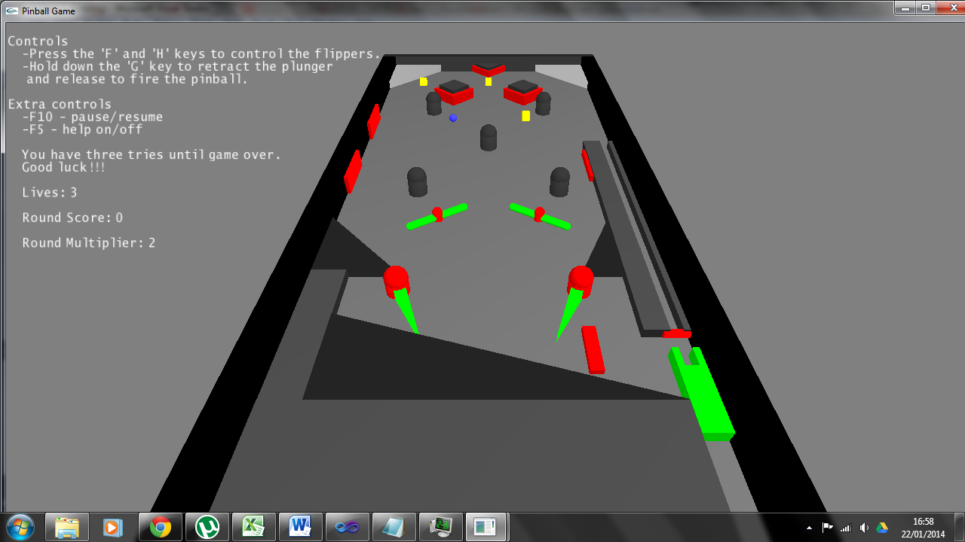

Original.

Fixed.

**Comment:** “Move the help text away from the pinball machine because it is in the way.”

**Solution:** The lines that were protruding over the pinball game were shortened by either removing text or moving part of the line to the one below. This means that the text doesn’t get in the way of what is happening in the game.

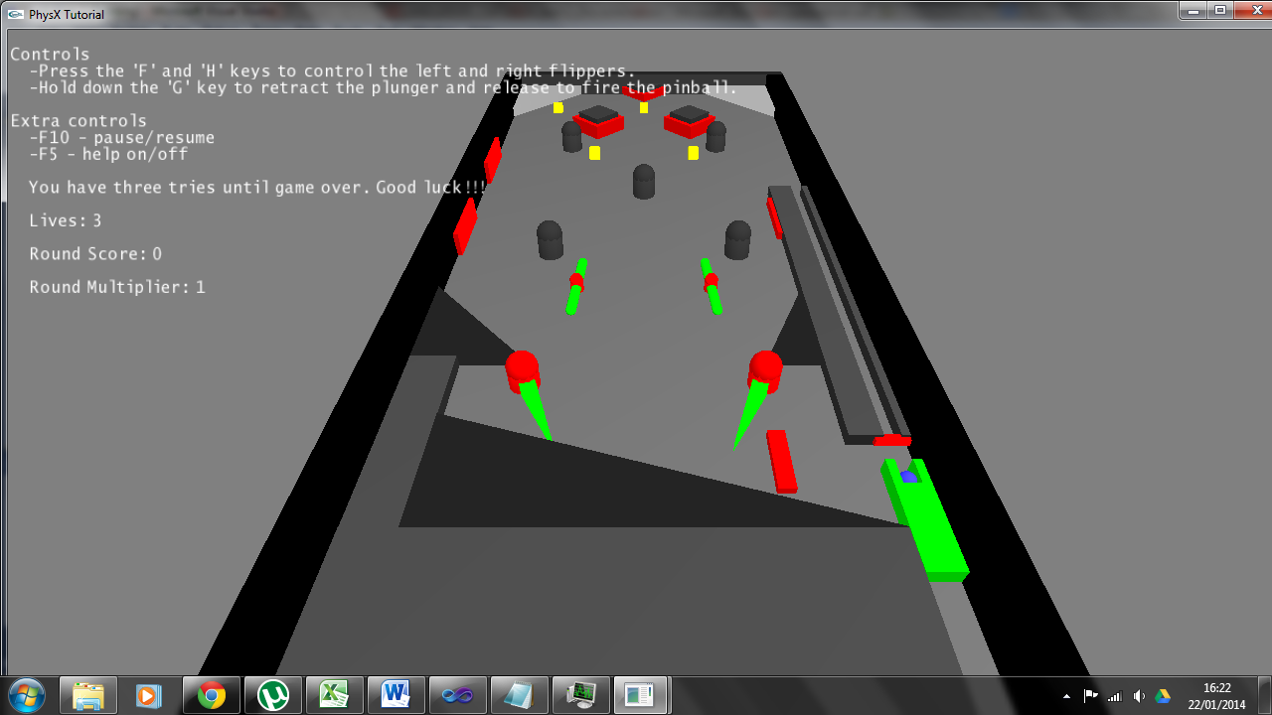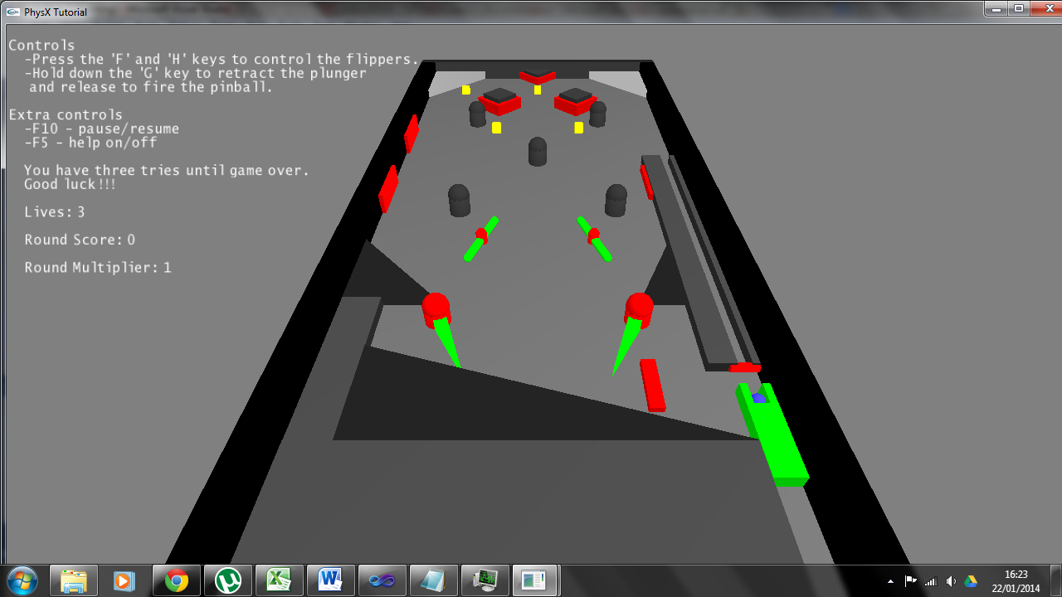

Original.

Fixed.